December 12th, 2022

To the Editors at PLOS Computational Biology,

Please find attached our paper “The nature of decision noise in random exploration.” In this paper we investigate the nature of behavioral variability and its role in exploration.

Behavioral variability has long been thought to be useful for exploration (e.g. Sutton & Barto 1998). By behaving “randomly,” we might try something new, which can lead to new insights into a problem or new ways to obtain reward. In line with this intuition, we recently showed that people become more random in their choices as the value of exploration is increased (Wilson et al. 2014). This finding suggests that people adapt behavioral variability in the service of exploration, but leaves open the question of how exactly they do it.

From a modeling perspective, behavioral variability is essentially the variance that can not be explained by a model and is modeled as the level of decision noise. However, what we have called ”decision noise” in previous research could actually just be missing deterministic components from the model, it is difficult to tell whether decision noise truly arises from a stochastic process.

In particular, there are two quite different ways in which people could alter their behavioral variability. In the “deterministic noise” strategy, they could simply pay more attention to irrelevant stimuli in the world, allowing the distraction of random deterministic cues to increase the variability in their response. In the “random noise” strategy, variable responding could be driven more directly, by random neural firing in the brain. Previous work makes a strong case for both types of noise being relevant to behavior. For instance, deterministic, stimulus-driven noise is thought to be a much greater source of choice variability in perceptual decisions than random neural noise (Brunton et al 2013). Conversely, random neural noise is thought to drive exploratory singing behavior in song birds and the generation of this random noise has been linked to specific neural structures. Thus it is unclear which type of noise humans would use for random exploration.

Using a modified version of our explore-exploit task, in which we controlled the stimuli and let people make decisions in repeated identical scenarios, we were able to statistically distinguish random and deterministic decision noise by assessing the degree to which human participants make consistent decisions. If noise is purely deterministic, then people should make identical choices in repeated scenarios. However, if noise is purely random, then people should be less consistent in their choices. By looking at the extent to which people make inconsistent choices and by fitting a novel Bayesian model in which deterministic noise and random noise can be separated, we were able to show that, while both random and deterministic noise were present in the explore-exploit choice, random noise is what’s dominant in driving exploration.

These findings suggest that random exploration is almost entirely driven by random noise and that human exploration in a cognitive decision making task looks very much like the motor exploration of song birds practicing their song. This suggests the intriguing idea that the noise generating neural circuits found in the song bird motor learning system, may also be present in humans and, more generally, may be a common method of exploration across species.

Given the broad implications of our findings and the growing interest in the causes of, and roles for, behavioral variability, we believe that our work will be of interest to a wide range of researchers in psychology, cognitive science and neuroscience. Our novel computational approach which separates deterministic noise from random noise should also be of interest to many computational scientists. As such we believe this paper is a good fit for PLOS Computational Biology.

Sincerely,

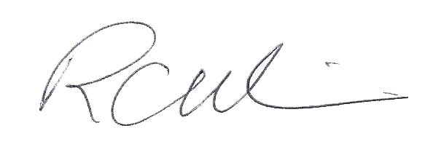

Robert Wilson, Ph.D.

**References**

B. W. Brunton, M. M. Botvinick, and C. D. Brody. Rats and humans can optimally accumulate evidence for decision-making. *Science*, 340(6128):95–98, Apr 2013.

M. H. Kao, A. J. Doupe, and M. S. Brainard. Contributions of an avian basal ganglia-forebrain circuit to real-time modulation of song. *Nature*, 433(7026):638–643, Feb 2005.

Sutton, R. S., Barto, A. G., & Bach, F. (1998). *Reinforcement learning: An introduction*. MIT press.

R. C. Wilson, A. Geana, J. M. White, E. A. Ludvig, and J. D. Cohen. Humans use directed and random exploration to solve the explore-exploit dilemma. *J Exp Psychol Gen*, 143(6):2074–2081, Dec 2014.